Unity Tutorial: 2D Shooting Mechanic

1. Create the scene

Set up the scene with a character where it has the PlayerMovement script enabled with 2D movement, ground where the character can move on and a weapon separate which is where a new script for ranged projectiles.

1. Setting up the weapon

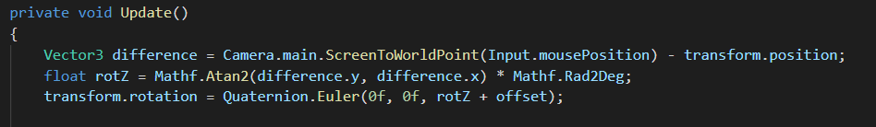In order to rotate the weapon with the mouse cursor it needs a calculated variable so the when moving the mouse in the game. Create a new C# script for the weapon and add public float offset; above the page to get the graphic to operate then add the code below as a private void Update() and after its functional, it can be tweak with the rotation based on angles in the scene.

1. Setting up projectiles

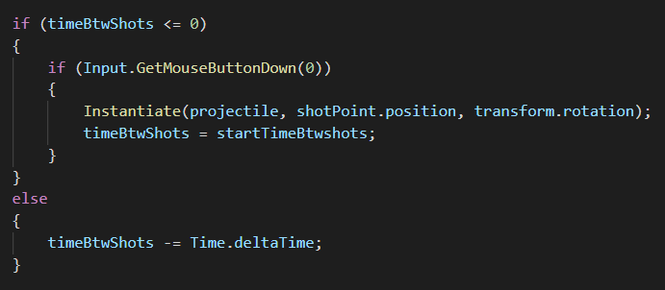Next in the script add public GameObject projectile; and public Transform shotPoint; which sets up the projectile asset once interacted in the game. Then add the code below which adds input and timing of projectiles when pressed. And finally add both [public float timeBtwshots;] [public float startTimeBtwshots;]. Make sure you have a projectile as a prefab and add to the weapon script in unity. Once the code is in place and when testing in the build, the projectiles are present but stationary.

1. Making a script for projectiles

In order to make the projectiles fire in a forward direction, create a new C# script add this code below and add the script to the projectile in the prefab and add the values and add the effect in the Destroy Effect and now it should be firing in the game build.

